* 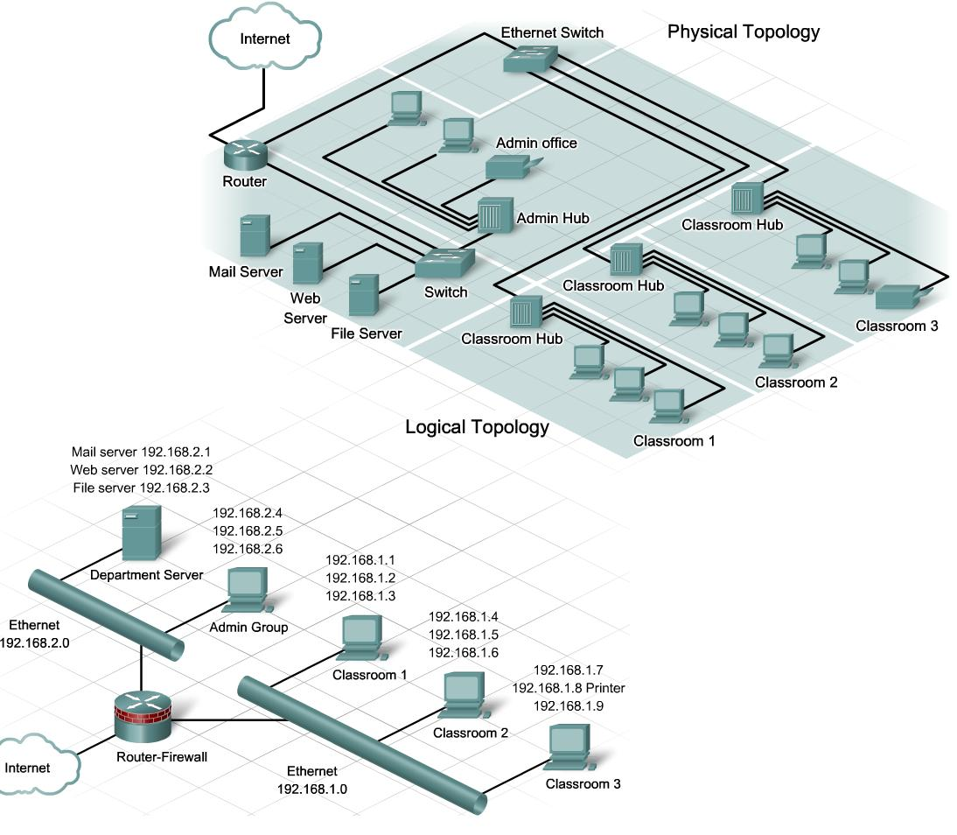
* Describes data transmission between nodes
* Most common: bus, ring
* Bus logical topology
* Signals travel from one device to all other devices
* May or may not travel through intervening connectivity device
* Bus logical topology used by networks with:
  + Physical bus topology & Star, star-wired bus topology
* Ethernet
* Ring logical topology
* Signals follow circular path
* Ring logical topology used by networks with:
  + Pure ring topology & Star-wired ring hybrid physical topology
* Token ring
* 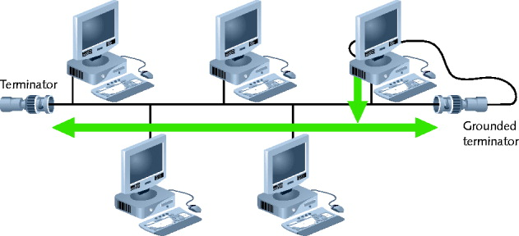
* Bus topology
* **Bus** -Single cable Connecting all network nodes No intervening connectivity devices **-** One shared communication channel
* **Physical medium -** Coaxial cable
* **Passive topology** - Node listens for, accepts data - Use broadcast to send
* Bus topology
* Broadcast domain -Node communicates using broadcast transmission
* Terminators - 50-ohm resistors - Stops signal at end of wire
* Signal bounce - Signal travel endlessly between two network ends
* One end grounded - Removes static electricity
* Advantages
* Relatively inexpensive
* Disadvantage
* Does not scale well
* Difficult to troubleshoot
* Not very fault tolerant
* 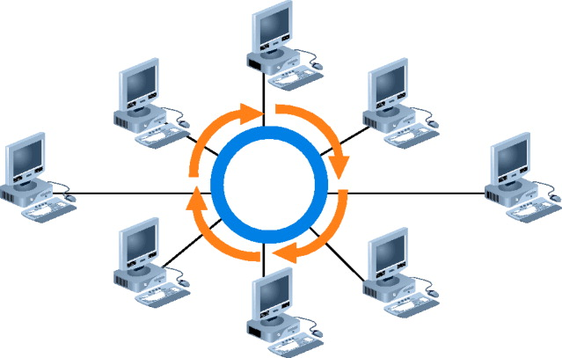
* Ring topology
* Node connects to nearest two nodes
* Circular network
* Clockwise data transmission
  + One direction (unidirectional) around ring
* Active topology
  + Workstation participates in data delivery
  + Data stops at destination
* Physical medium
  + Twisted pair or fiber-optic cabling
* 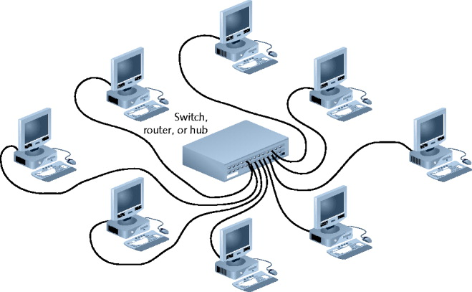
* Star topology
* Node connects through central device
* Physical medium
  + Twisted pair or fiber-optic cabling
* Single cable connects two devices
* Require more cabling, configuration
* Advantage
* Fault tolerance
  + Centralized connection point affects LAN segment
* Scalable
* 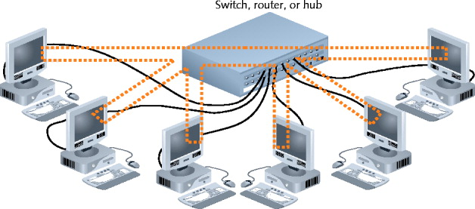
* Star-wired bus topology
* Workstation groups
  + Star-connected devices
  + Networked via single bus
* Advantage
* Cover longer distances
* Easily interconnect, isolate different segments
* Drawback
* Cabling, connectivity device expense
* Basis for modern Ethernet networks

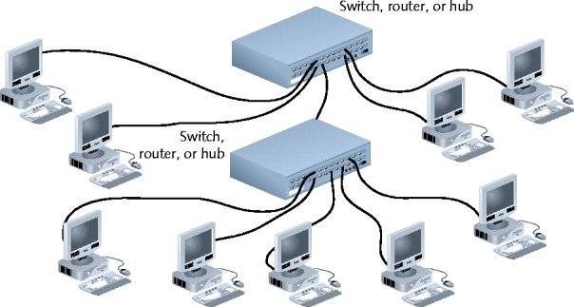

Figure 5-5 A star-wired bus topology network

* **topology** describes how the parts of a whole work together
* most network diagrams provide broad snapshots of a network’s physical or logical topology
* **physical topology** or network typology, mostly applies to hardware and describes how computers, other devises, and cables fit together to form the physical network
  + the physical topology used by the network is called a star topology because all devise connect to one central device, the switch
  + the physical layout of the media, nodes, and devise on a network
  + a physical topology does not specify device types, connectivity methods, or addressing schemes
  + physical topologies are categorized into three fundamental shapes: bus, ring, and star
    - these shapes can be mixed to create hybrid topologies
* **logical topology** has to do with software and describes how access to the network is controlled, including how users and programs initially gain access to the network and how specific resources, such as applications and databases, are shared on the network
  + a characteristic of network transmission that reflects the way in which data is transmitted between nodes
  + a network’s logical topology may differ from its physical topology